# NFL MVP Site Plan

## Owen Heap

## WDD 130

## Overview

### Purpose

To explain why Justin Herbert should win the MVP award in the NFL in the 2025 season

### Audience

Sports fans that are interested in the NFL

## Branding

### Website Logo

## Style Guide

### Color Palette

|  |  |  |  |
| --- | --- | --- | --- |
| **Primary** | **Secondary** | **Accent 1** | **Accent 2** |
| **Powder Blue:** #0073CF | **Sunshine Gold:** #FFC20E | **Navy Blue:** #002244 | **White Smoke:** #F5F5F5 |



### Typography

#### Heading Font: Impact

#### Paragraph Font: Roboto

### Navigation

View The Analytics Understand the Context See the Case

**Content**

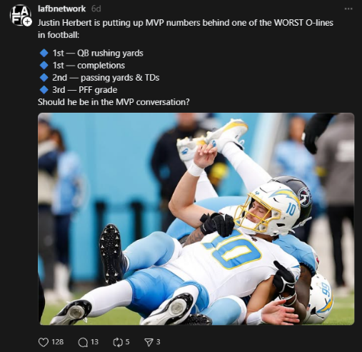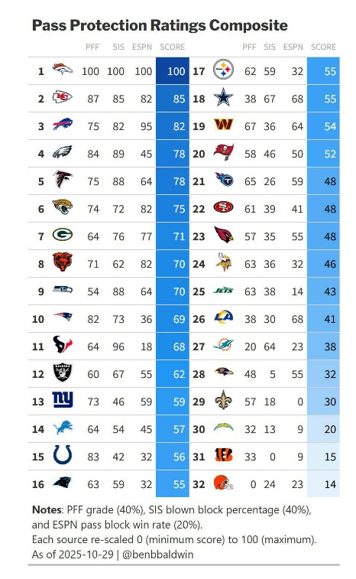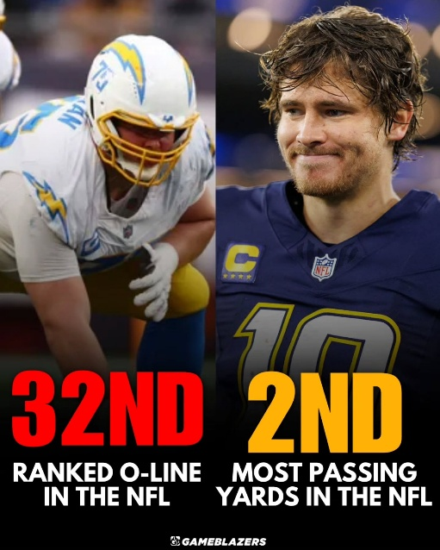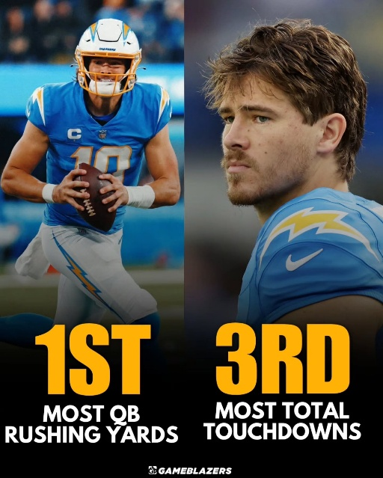

**Wireframes**

### 